How to change the no results message to a specific message in an Analytics report | 
Yoel Kortick
Senior Librarian

By default an Alma analytics report with no results will appear as follows (with the filter being the specific filter for the specific report)

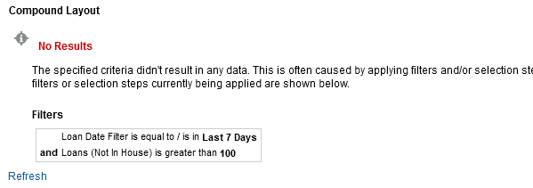

It is possible however to change this in the following manner.

ONE
From the criteria tab choose “Edit Analysis Properties”

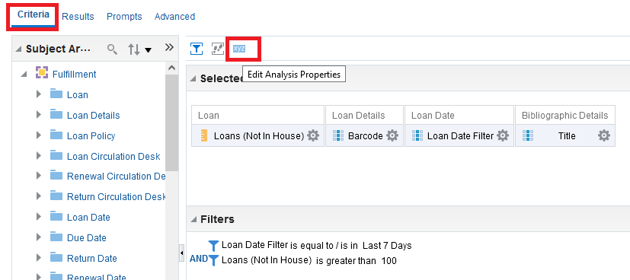

TWO

In the ‘Results Display’ tab choose ‘Display Custom Message’

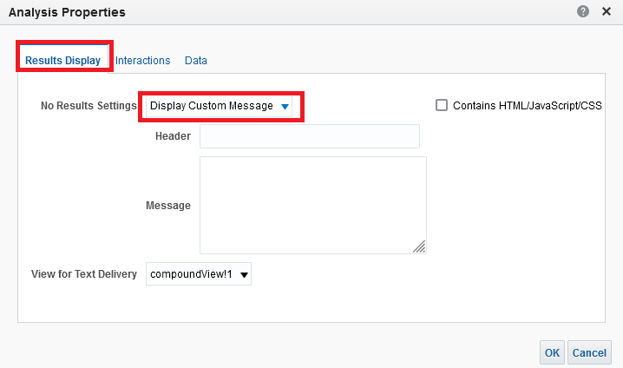

THREE

This is what will appear when the report has no results.
- The text entered in the “Header” field will by default be red bold.
- The text in the “Message” field will appear under the header. It is possible to use html tags in the message.

Below
Our header is “No results for query”
Our message is “There are no items with <b>more than 100</b> loans in the last 7 days”

Note that we have checked the box “Contains HTML/Java Scrcipt/CSS”

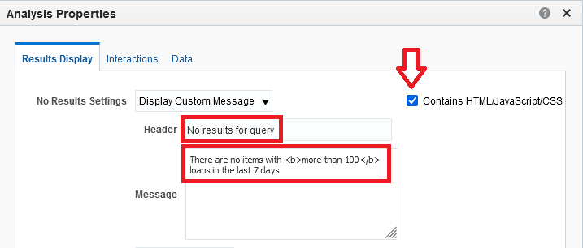

FOUR

See results

